* **ABSTRACT**

SHOE BUZZ was taken by me and my project partners on 5th semester for B.C.A. at PKM COLLEGE-JUNAGADH under BHAKTKAVINARSHIMEHTAUNIVERSITY.

I am deeply grateful to the persons who are directly or indirectly Involved with this project and who have help me completing this Project successfully.

First of all I am grateful to my project guide Prof. Manshi mem who has guided me though the project. Their encouragement guidance helped me to take this kind of live project and complete it by the time.

My other classmates who inspired me and my friends who gave me valuable suggestions are also part of my project work.

And last but not the least, my family members who supported me throughout my study, helped me immensely in the project also.

I am thankful to SHREE P.K.M. COLLEGE for all the facilities they provide me. And I would like to thanks all staff members of my college.

**Prem Parmar**

**Jeet Kotecha**

* **ACKNOWLEDGEMENT**

We sincere “THANKS” goes to:

We have thankful to all people to contribute in this project. And also thanks to this people to helpful us. We would like to thank without whose support and inspiration this project is not successfully accomplished. We have first of all thanks to our guide Miss Manshi mem who took us in the right path for the web application development and they have been also provide the suggestion and advice. We are also thanks to our head of department **Jitendra** **Radadiya Sir** they are given us to knowledge about the good software developer.

We are also very thankful to our Director **MR. Praful Kanjiya Sir** and our respective principal **DR. Alkesh Vachhani Sir** who gave us an opportunity to present this project.

* **DECLARATION**

We **Prem Parmar , Jeet Kotecha** are Bonafide student of B.C.A in SHREE PATEL KELAVANI MANDAL COLLEGE OF TECHNOLOGY AND B.ED. would like to declare that the project report entitled “PKM COLLEGE” submitted by using partial fulfilment of the requirement of the completion of B.C.A SEM-5 is my original work.

1._________________

2._________________

(Student’s signature)

* **INDEX**

|  |  |  |
| --- | --- | --- |
| Sr.no | Title | Page no |
| (1) | **Project Introduction** | 5 |
|  | 1. Project Profile | 6 |
|  | 1. Requirement Gathering | 7 |
|  | **:-** Question/answering | 8 |
|  | **:-** Information Report | 9 |
|  | 3)Requirement Analysis | 10 |
|  | 4)project Modules | 11 |
| (2) | **System Study** |  |
|  | 1)Project Planning | 13 |
|  | 2)Time line chart | 13 |
|  | 3)Feasibility study | 14 |
|  | **:-** Operational Feasibility | 14 |
|  | **:-** Technical Feasibility | 16 |
|  | **:-** Economical Feasibility | 17 |
| (3) | **System Flow** |  |
|  | 1)Normalization | 18 |
|  | 2)Data Dictionary | 22 |
|  | 3)Data Diagrams |  |
|  | **:-** Data Flow Diagram | 29 |
|  | **:-** E-R Diagram | 32 |
|  | **:-** Use Case Diagram | 34 |
|  | **:-** Activity Diagram | 36 |
| (4) | **System Design** | 38 |
| (5) | **Testing** |  |
|  | 1)Manual Testing | 50 |
|  | **:-** Test Case | 50 |
| (6) | **Conclusion** | 52 |
| (7) | **Bibliography** | 52 |
| (8) | **Project Task Report Include Project Guide Remarks** | 53 |

* **PROJECT INTRODUCTION**

• In today ‘s digital age, e-commerce has revolutionized the way consumers shop for products, making it essential for businesses to establish a robust online presence.

* This project focuses on the development of an online shoe store using PHP, aimed at providing user with a seamless shopping experience while offering a wide range of footwear option.
* The primary goal of this project is to create platform.
* **PROJECT PROFILE**

|  |  |
| --- | --- |
| Project Title | “SHOE BUZZ” |
| Project Description | This Project of “Online Shoes Store” Project develop order food online and reduce time. |
| Project Duration | 3 Months |
| Project Guide | Prof. Manshi ponkiya |
| Platform | Application will be embedded with windows 11.  professional and deployed with Vscode. |
| Tool Used | 1. Editor use : Visual Studio code 2. Web server : Xampp 3. Browser : Google chrome |
| Front End | HTML,CSS& JavaScript |
| Back End | PHP &MYSQL |
| Team Member | 2 |
| Name Of Team Member | 1. Prem Parmar 2. Jeet Kotecha |
| Submitted to College | Shree P.K.M. College Of Technology & B.ED. -JUNAGADH |
| Submitted to University | Bhakt Kavi Narshi Mehta University-Junagadh |

* **REQUIREMENT GATHERING**
* “In this phase of SDLC necessary information is collected we have collected information in this phase of our project development though different web sites”.
* “Requirement gathering is the most important and fundamental stage in SDLC”.
* There are mainly four types of requirement gathering.

|  |  |
| --- | --- |
| **A** | **Interviews** |
| **B** | **Questionnaires** |
| **C** | **Record Reviews** |
| **D** | **Observation** |

* But we choose questionnaires option.
* Above four types we choose “Questionnaires”.
* **QUESTIONNARES**
* Questionnaire are special purpose document that allow the analyst to collect information and opinions from respondent by above four types we choose “Questionnaires “.
* **Questions :-**

1. **Do you ship?**

* Yes, if you are living in another country then we offer ship for you

1. **Do you Deliver?**

* Yes

1. **When will I get my orders?**

* We will ship your product 2-3 days around Negros

Occidental and it will take 4-6 days Nationwide.

1. **Can you give return policy?**

* “Yes, we can give return policy”.

1. **How many days return policy Can you provide?**

* We offer a 7 days return policy.

1. **Are you giving free home delivery?**

* Yes , we can not take any changes for home delivery

1. **Have you provide any discount?**

* “Yes, we provides 10% discount sometimes and

sometimes we provide 10 to 49% discount”.

1. **Which method you choose for payment?**

* We choose Cash on delivery.
* **INFORMATION REPORT**
* Existing system& requirement of new system
* In the existing system all transactions, dealings of is time consuming.
* In the existing system many category and a few shoes which is very limited.
* Reports are prepared manually as and when needed. Maintaining of report is very tedious task.
* There is no computer system for handling payments. All calculations are performed manually which may not be accurate always.
* Need for the new system is major drawbacks of existing system.
* Report can be generated at any time within few seconds, so that manual report is not required and also analysis can be performed much more frequently which helps in taking decision.
* Very helpful can also be maintained as their information is very helpful and sometimes becomes a critical requirement.
* **REQUIREMENT ANALYSIS**
* Requirement analysis is one of the most important phases in the life cycle of the software development. In requirement analysis the developer should know the requirements of the user and all the facilities they needed.

|  |  |
| --- | --- |
| CLIENT | ADMIN |
| Login | Login |
| Home | Dashboard |
| Products | Products |
| About us | Transactions |
| Contact us | Customers |
| Privacy policy | Messages |
| FAQs | Orders |
| Logout | Logout |

* **Project Modules**
* ADMIN



* CLIENT



* **SYSTEM STUDY**
* **Project Planning**

|  |  |  |  |
| --- | --- | --- | --- |
| No | Task | Starting Date | End Date |
| 1 | Information Gathering | 1-7-2024 | 15-7-2024 |
| 2 | Analysis | 16-7-2024 | 22-7-2024 |
| 3 | Database Design | 23-7-2024 | 28-7-2024 |
| 4 | System Design & Codding | 29-7-2024 | 29-8-2024 |
| 5 | Implementation & Testing | 30-8-2024 | 10-9-2024 |
| 6 | Documentation | 11-9-2024 | 25-9-2024 |

* **TIME LINE CHART**
* **FEASIBLITY STUDY**
* A feasibility analysis usually involves a thorough assessment of the operational(need), financial and technical aspects of a proposal.
* The feasibility study concluded that project would be able to be implemented to success as if was carefully planned.
* **There are three type of feasibility…**

1. Operational feasibility …
2. Technical feasibility…
3. Economical feasibility…
4. **Operational feasibility :-**

* Whether the problem can be solved in the user’s environment with existing and proposed system workings.
* User : user, admin.

|  |  |  |  |
| --- | --- | --- | --- |
| Page | Process | Effected Table | Operation |
| Login | Check the login process | Admin | Insert,Update,Delete |
| Order | Manage order | Admin | Delivered, Delete |
| Support | Show message | Admin | Insert, Delete |
| User | Manage User | Admin | View ,Delete |
| Add books | Add books,  View books | Admin | Update,insert,Delete |
| category | Add & manage category | Category | Edit,view,Delete |
| Logout | Logout | Logout | Logout |

* **Function that performed by : Admin**
* **Function that performed by: User/Client**

|  |  |  |  |
| --- | --- | --- | --- |
| Page | Process | Affected Table | Operation |
| Registration | Registration | Registration | Insert |
| Login | Check the login process | Registration | Select |
| Product | View product | Product | View,Select |
| About us | View About Information | About us | View |
| Category | View category | Category | View |
| Ordered | View order | Books | Add,View |
| Cart | View cart | Cart | View |
| Contact | Add contact | Contact | Insert |

**2. Technical feasibility :-**

* Weather it is technical possible with the existing technology or with the planned new technology.
* **Hardware & Software specification.**

|  |  |
| --- | --- |
| Component | Minimum Requirements |
| Processor | 1.6 GHZ processor or above |
| Supported Architecture | 32 bit (*84)  64bit (*64) |
| Memory | 1 GB or above ddr3 |
| Hard disk | Total space:250 GB |

* **Minimum Hardware Requirement :**
* **Minimum Software Requirement :**

|  |  |
| --- | --- |
| Component1 | Minimum Requirements |
| Operating System | Windows 11 or higher |
| Database | MySQL |
| Web Server | Apache & MySQL |
| Web Browser | Google Chrome and as above |
| Other Tools | Visual Studio, RFFlow ,XAMPP, Word |

**3.Economical feasibility :-**

* The purpose of an economic feasibility to determine the

Net benefit of the project

* **Hardware Study :**

|  |  |  |  |
| --- | --- | --- | --- |
| Component | Requirements | Price | Website/Shop |
| Processor | 2.80 GHz processor intel i5 | 10000 | [www.filpcart.com](http://www.filpcart.com) |
| Hard disk | 512GB | 3000 | [www.hardwire.com](http://www.hardwire.com) |
| Memory | 8GB RAM DDR3 (transcend) | 1365 | [www.amazon.com](http://www.amazon.com) |

* **Software Study :**

|  |  |  |
| --- | --- | --- |
| Component | Price | Website/Shop |
| Window 11 | 4470 | [www.filpcart.com](http://www.filpcart.com) |
| SQL Service of XAMPP | FREE | [WWW.MYSQL.COM](http://WWW.MYSQL.COM) |
| Google Chrome | FREE | [www.chrome.org](http://www.chrome.org) |
| Visual Code | FREE | [www.Visualstudiocode.com](http://www.Visualstudiocode.com) |

* **SYSTEM FLOW**
* NORMALIZATION
* “Database Normalization is the process of organizing the columns tables of relation database to minimize data redundancy”.
* Normalization usually involves dividing a database in two or more tables and defining relationship between the tables.
* **First Normalization :-**
* A database is in first normal form if it satisfies the following conditions:
* Contains only automatic values and there are no repeating groups
* Attributes for admin,cart,message,order,product,user tables.

|  |
| --- |
| ID |
| Username |
| Email |
| Zip Code |
| Password |
| Address |
| Mobile |

* **Second Normalization :-**
* A database is a second normal form if it satisfies the following condition.
* It is in first normal form.
* All non-key attributes are fully functional dependent on primary key.

|  |
| --- |
| PRODUCT |
| cid |
| Category |
| description |

|  |
| --- |
| REGISTRATION |
| First name |
| Middle name |
| Last name |
| Address |
| Province |
| Zip code |
| Mobile number |
| Telephone number |
| Email |
| Password |

|  |
| --- |
| LOGIN |
| Email |
| Password |

* **Third Normalization :-**

|  |
| --- |
| Admin |
| Adminid |
| Username |
| Password |

|  |
| --- |
| Contact |
| Contact_id |
| Email |
| Message |

|  |
| --- |
| Product |
| Product_id |
| Product_name |
| Product_price |
| Product_size |
| Product_image |
| Brand |
| Category |

|  |
| --- |
| Stock |
| Stock_id |
| Product_id |
| Oty |

|  |
| --- |
| Transaction |
| transaction_id |
| Customerid |
| Amount |
| Order_stat |
| Order_date |

|  |
| --- |
| Transaction_Detail |
| transaction_detail_id |
| Product_id |
| Order_qty |
| transaction_id |

* **DATA DICTIONARY**
* “A Data Dictionary defines the structure of the database itself and is used in control and maintenance database.”
* **Database:**

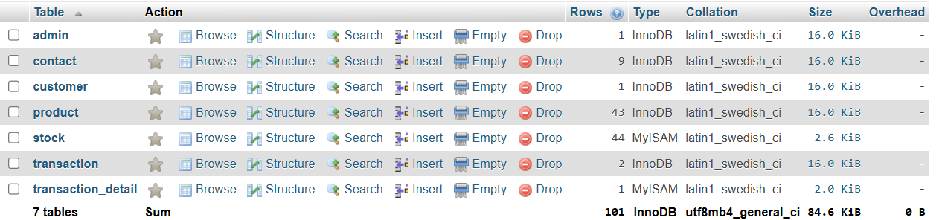

* **Admin:**

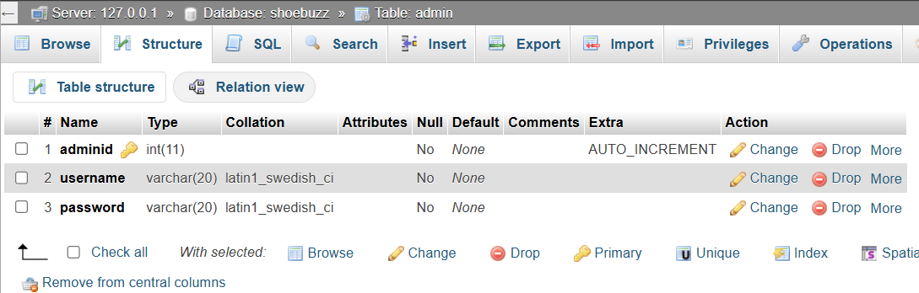

* **Contact:**

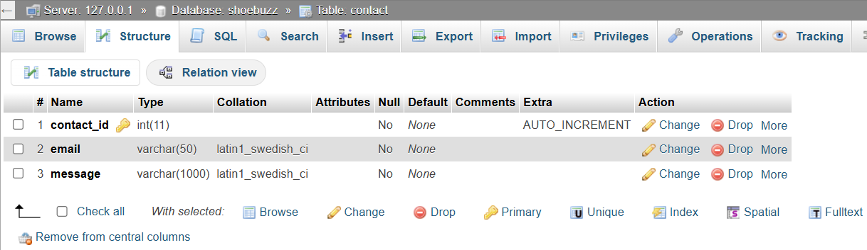

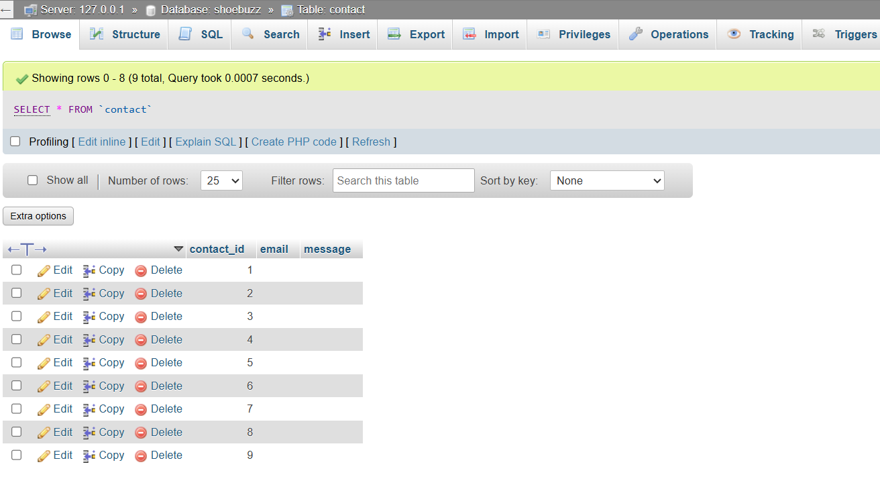

* **Customer:**

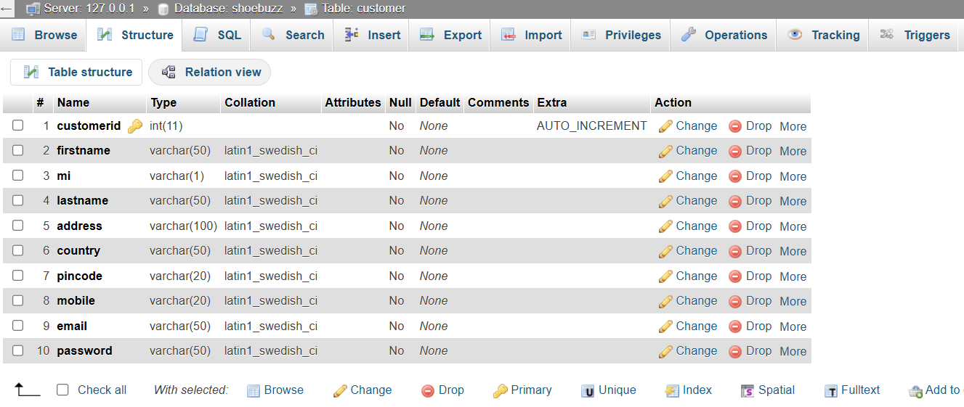

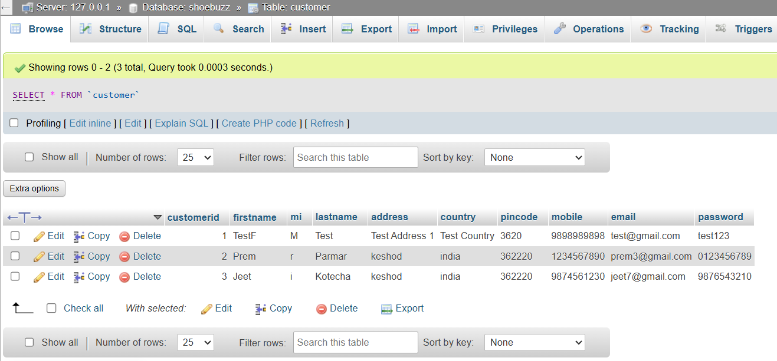

* **Products:**

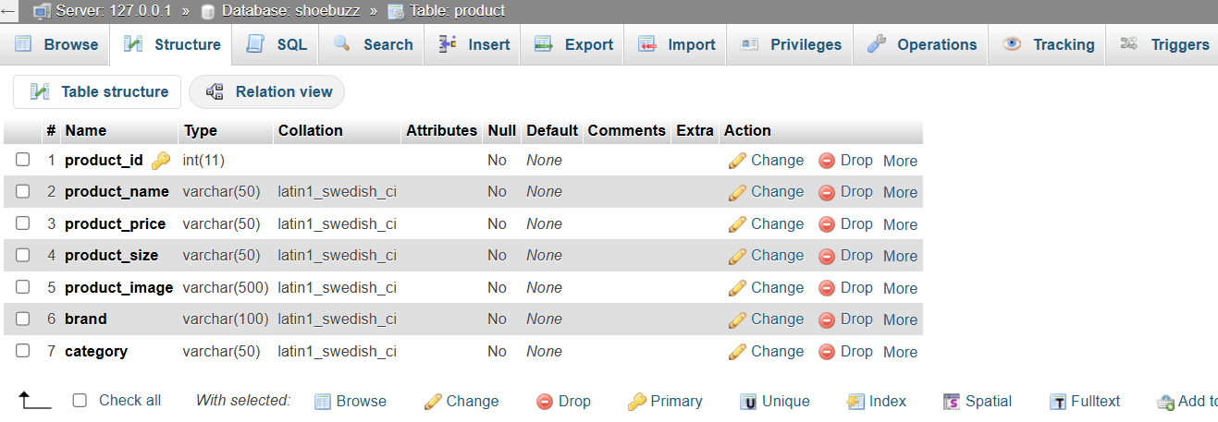

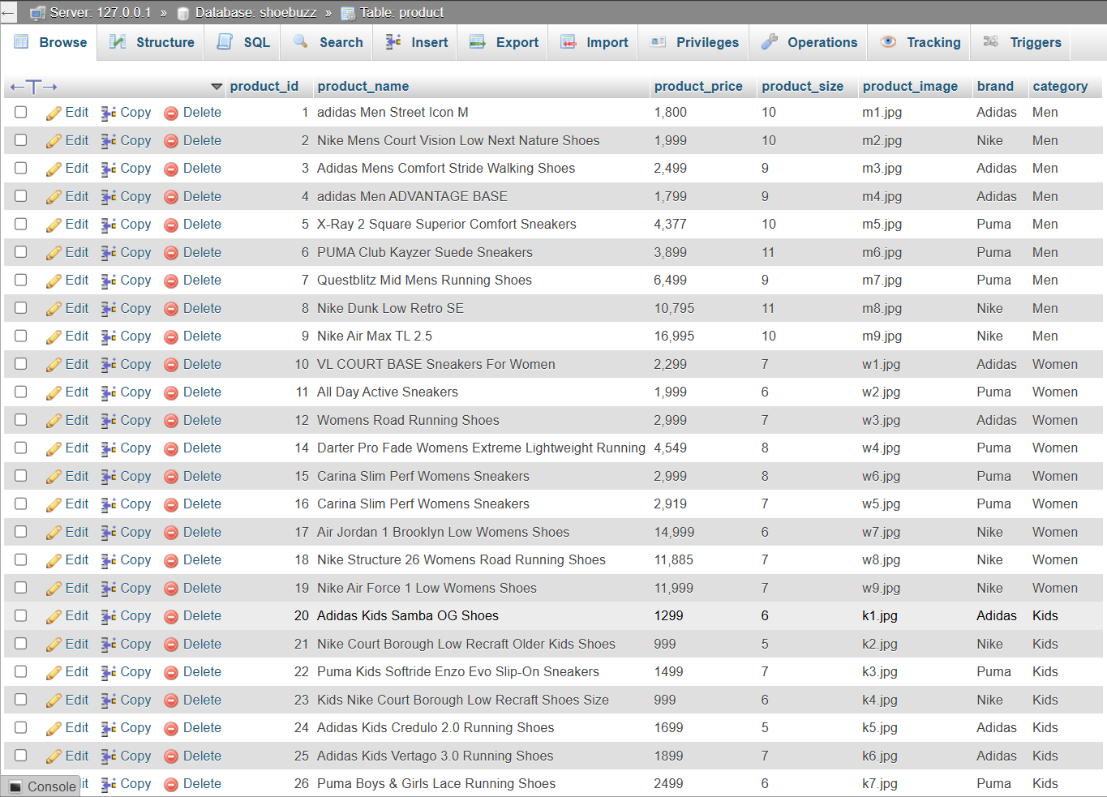

* **Stock:**

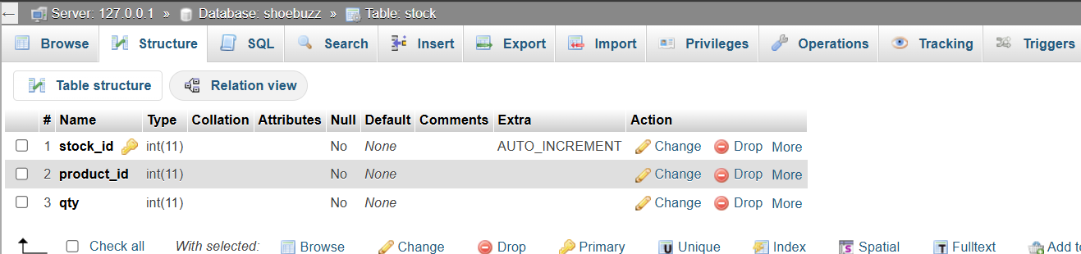

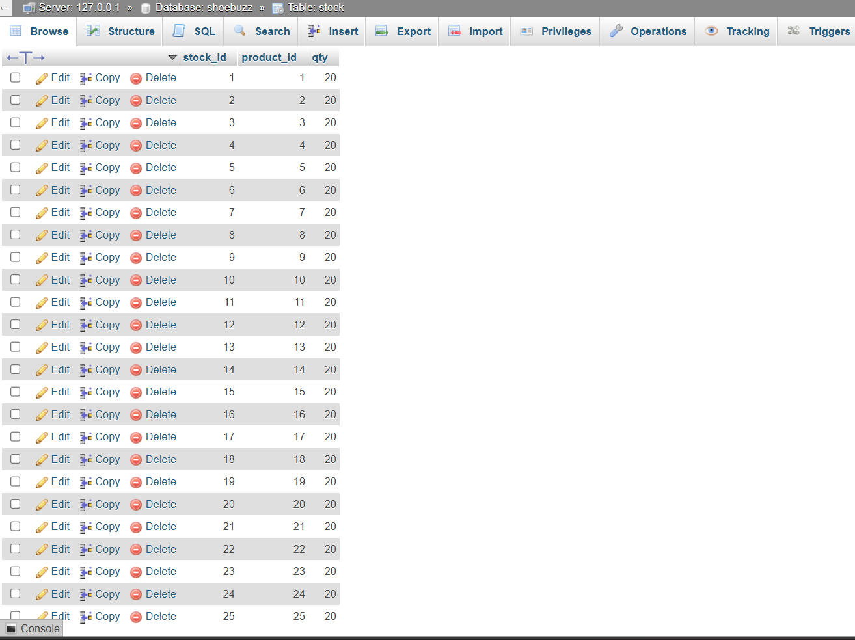

* **Transactions:**

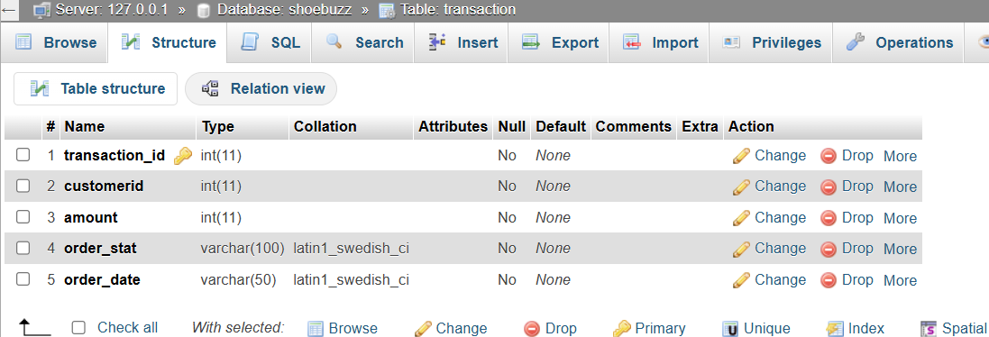

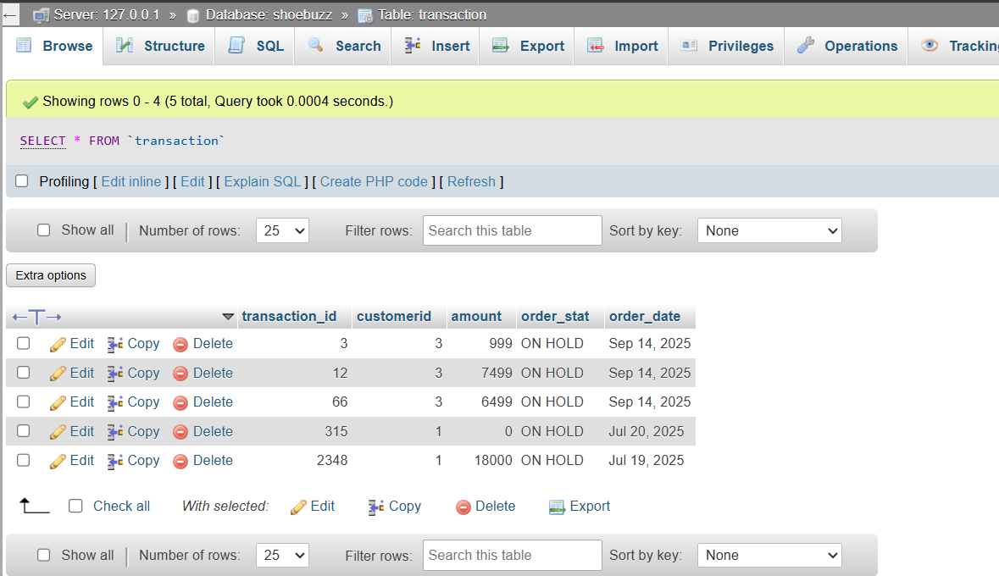

* **Transactions Details:**

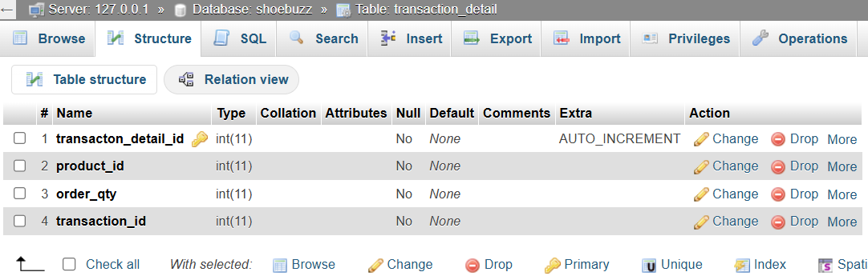

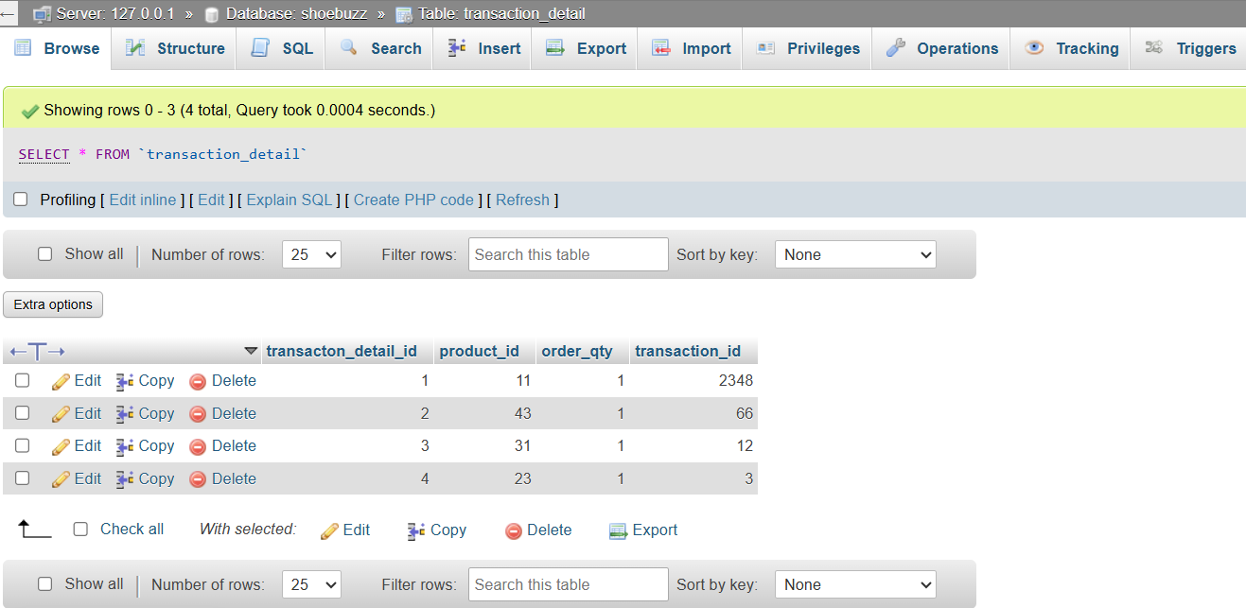

* **Data Diagram**
* **DATA FLOW DIAGRAM**
* A DFD is a graphical repetition on the “flow” of data through an information system modelling its procaspases.
* **0 LEVEL DFD**



* **1st Level DFD for Admin:**



* **1st Level DFD for Client:**



* **E-R DIAGRAM**
* **Entity Relationship Diagram:**
* “An E-R diagram is a chat that visually represents the relationship between database entities. “



* **E-R DIAGRAM :**



* **Use Case For Admin:**



* **Use Case For Client:**



* **ACTIVITY DIAGRAM**
* **Admin:**



* **Client:**



* **SYSTEM DESIGN**
* **ADMIN LOGIN:**

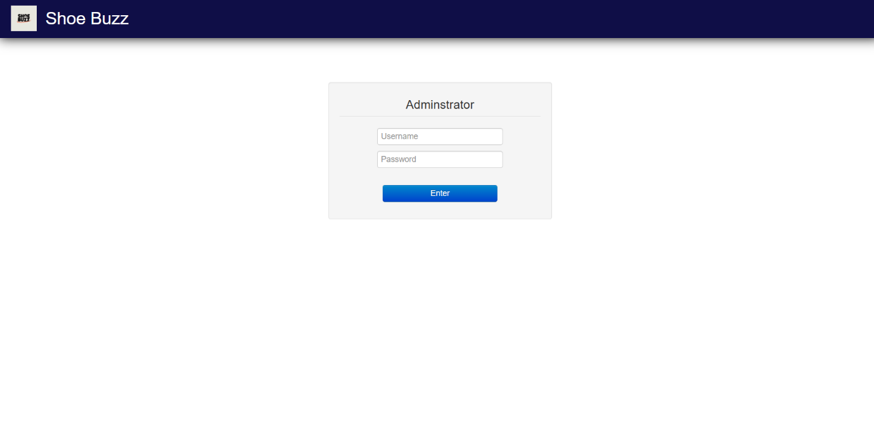

* **ADMIN DASHBOARD:**

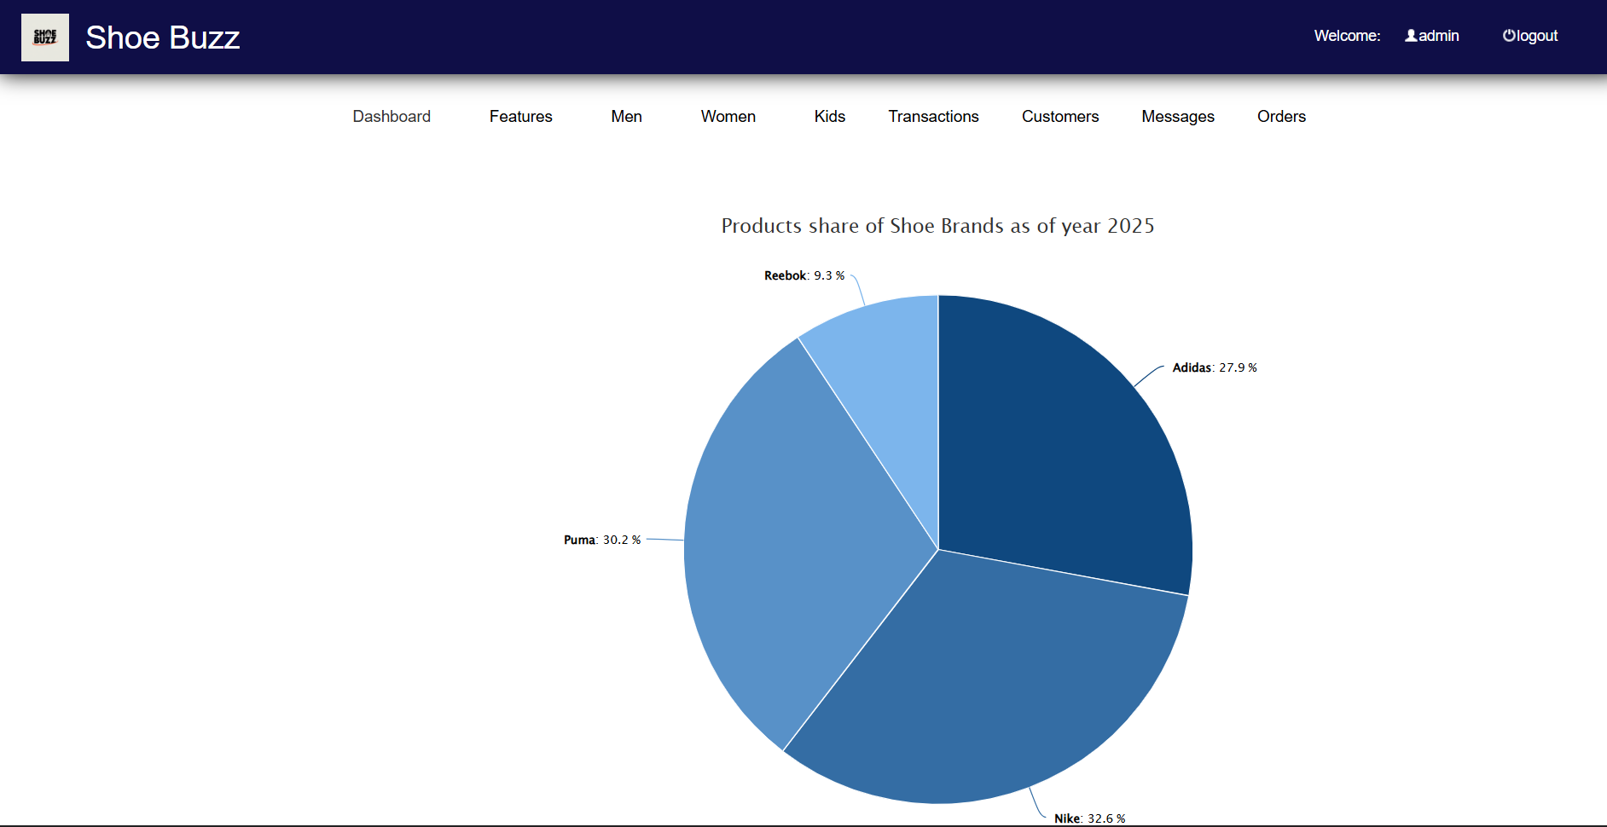

* **PRODUCTS:**
* **FEATURES**

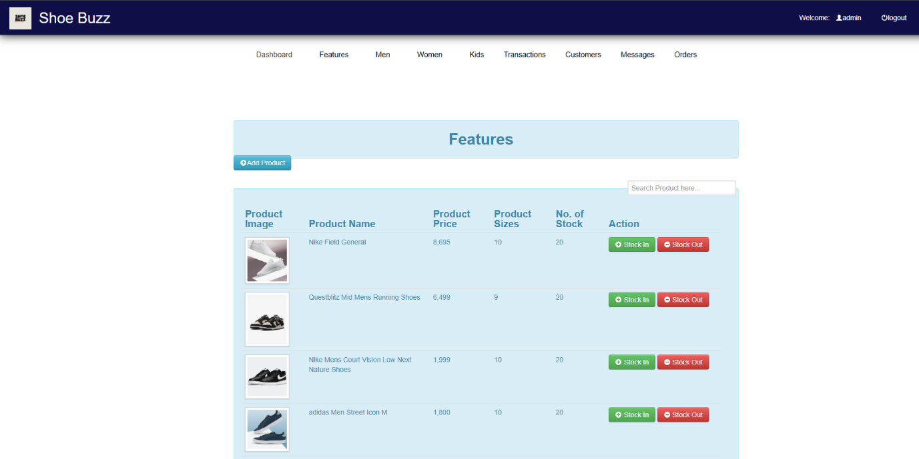

* **MEN:**

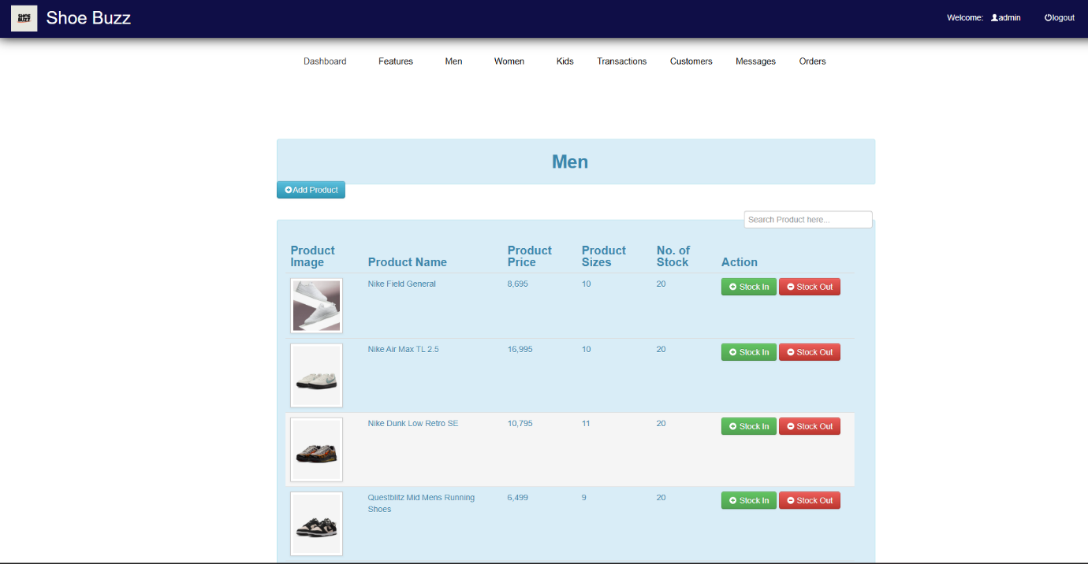

* **WOMEN:**

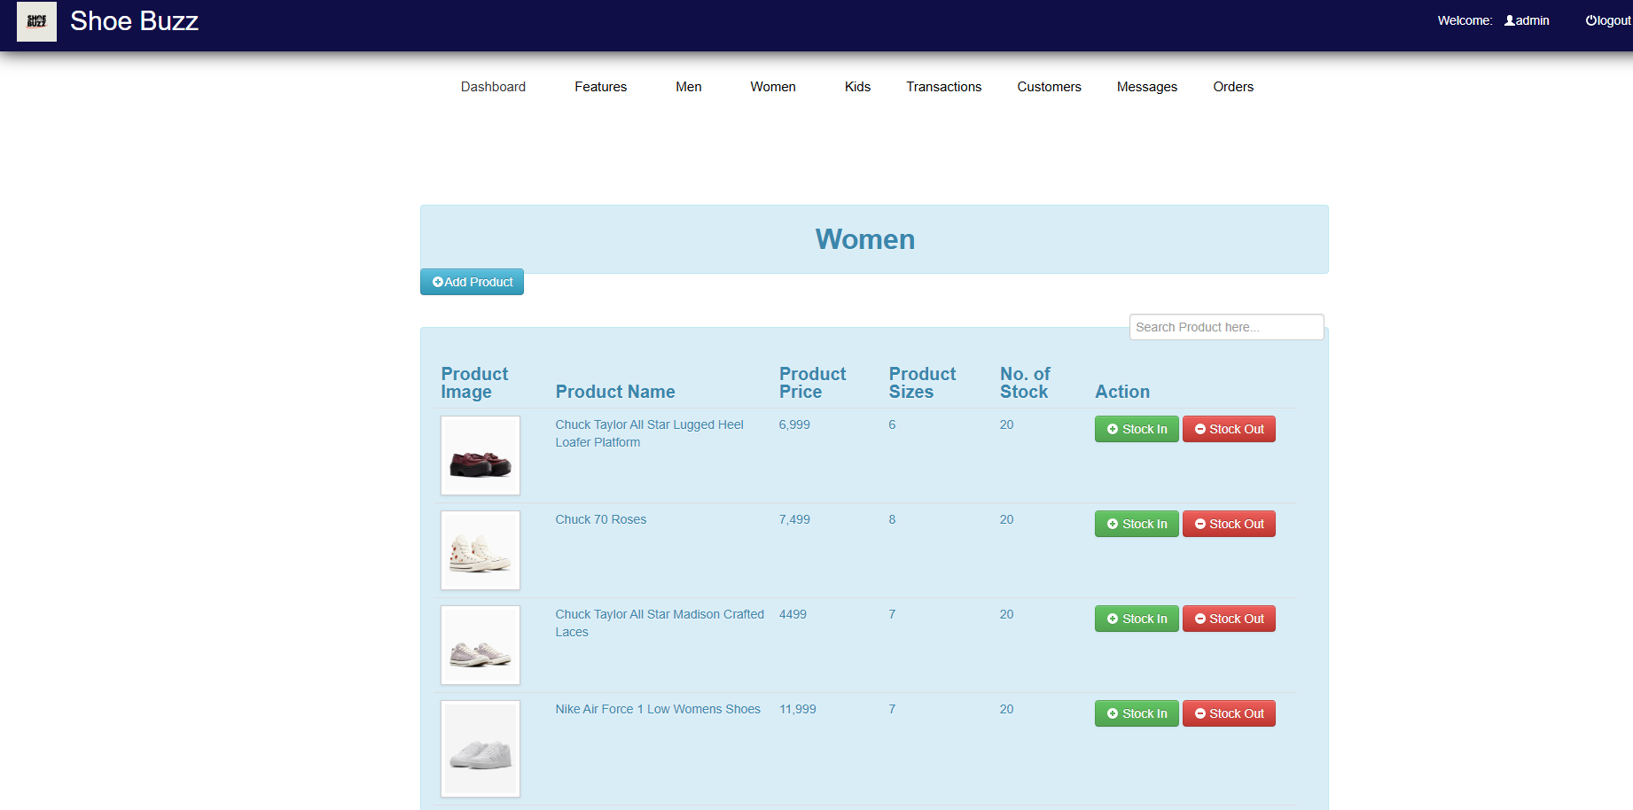

* **KIDS:**

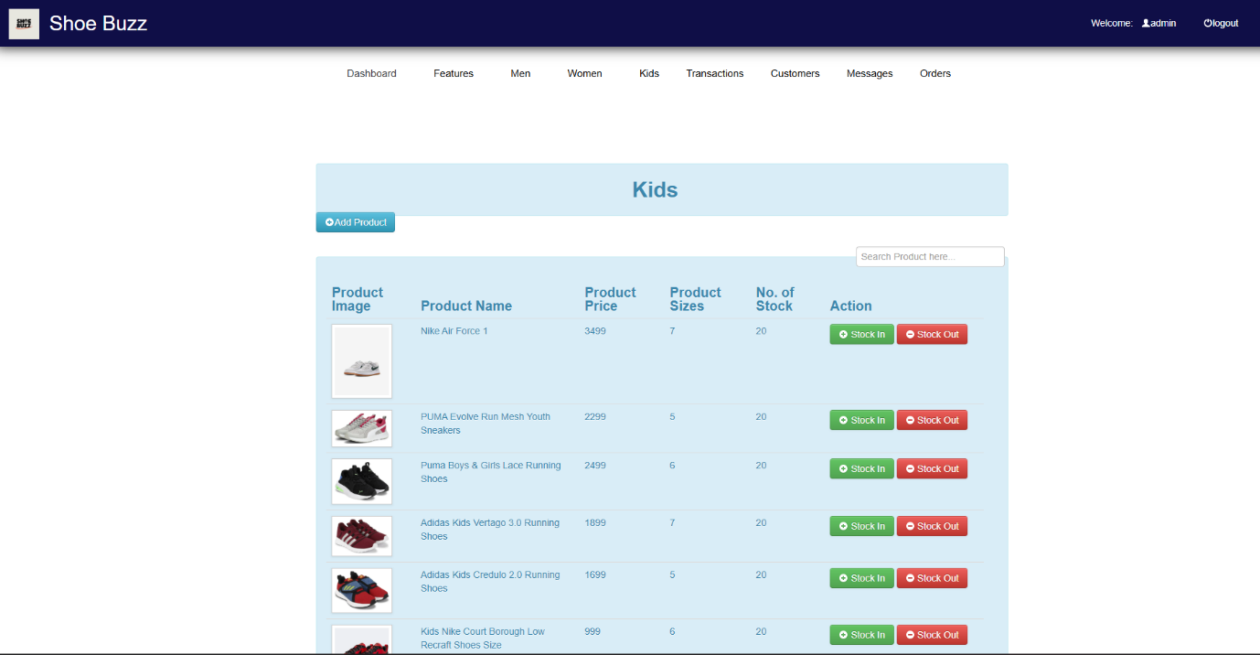

* **TRANSACTION:**

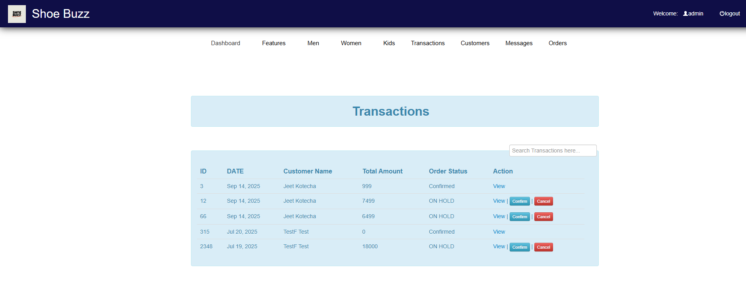

* **CUSTOMERS:**

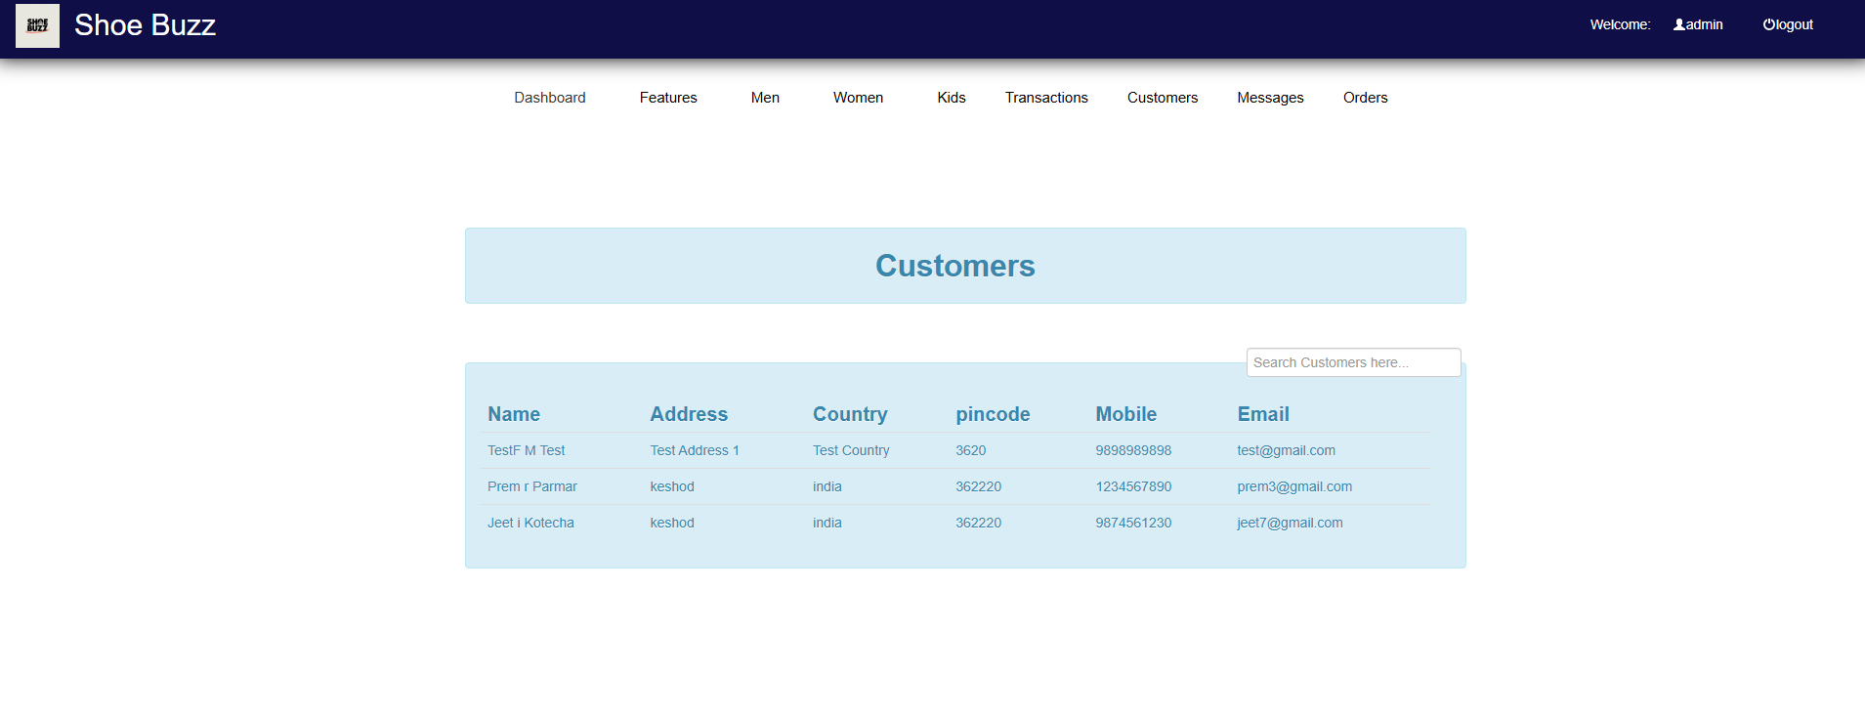

* **MESSAGES:**

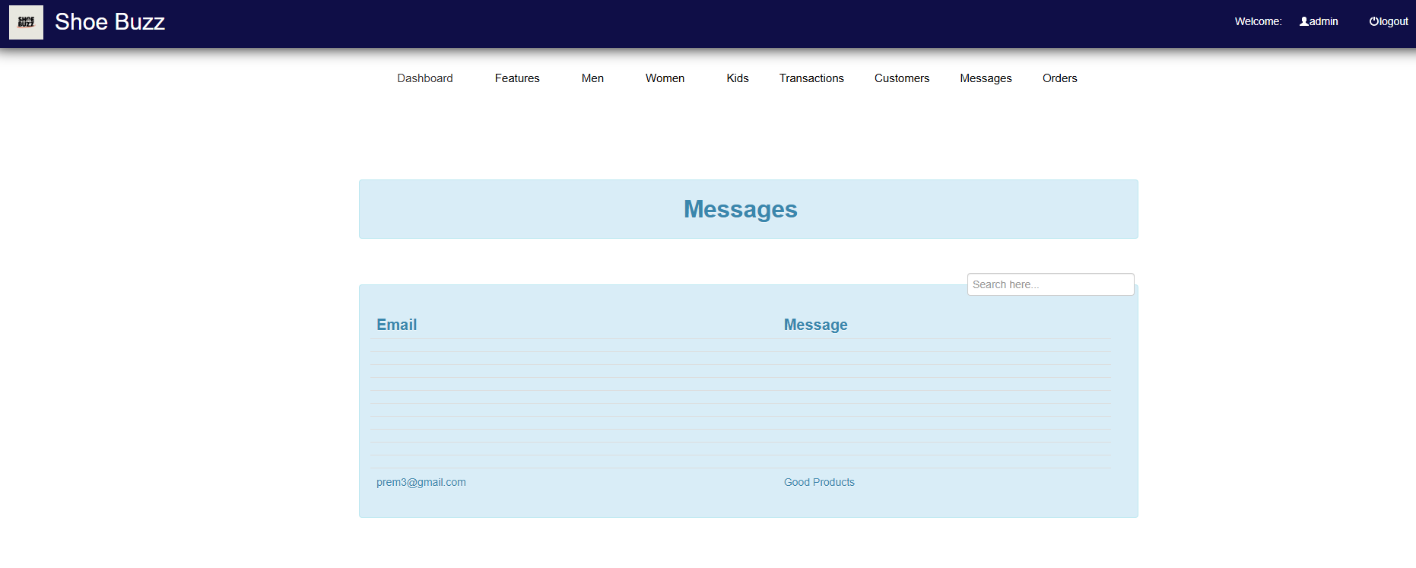

* **ORDERS:**

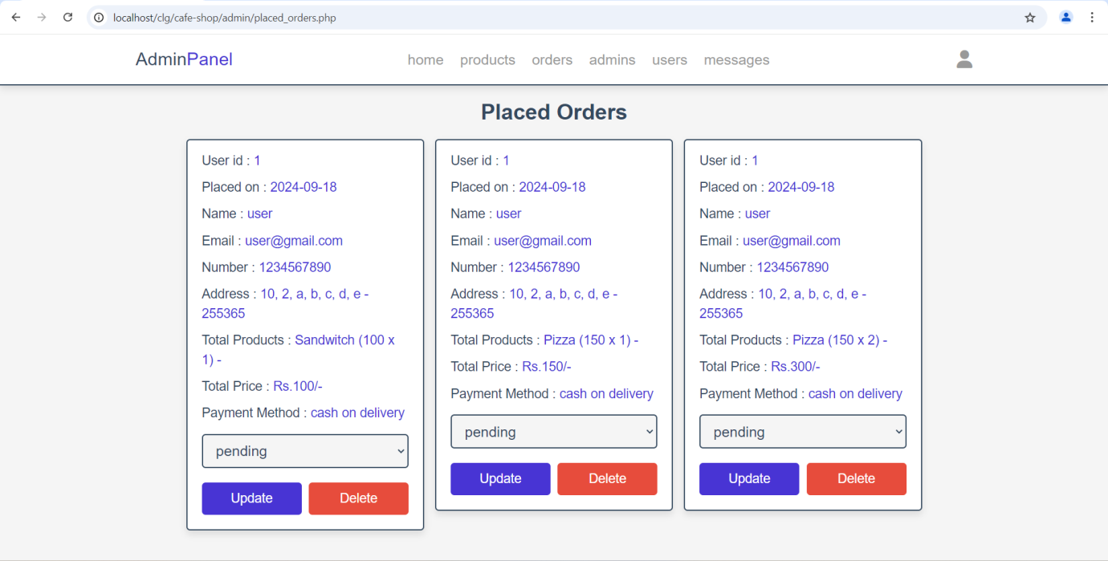

* **SYSTEM DESIGN**
* **CLIENT SIDE DESIGN:**
* **CLIENT SIDE HOME PAGE:**

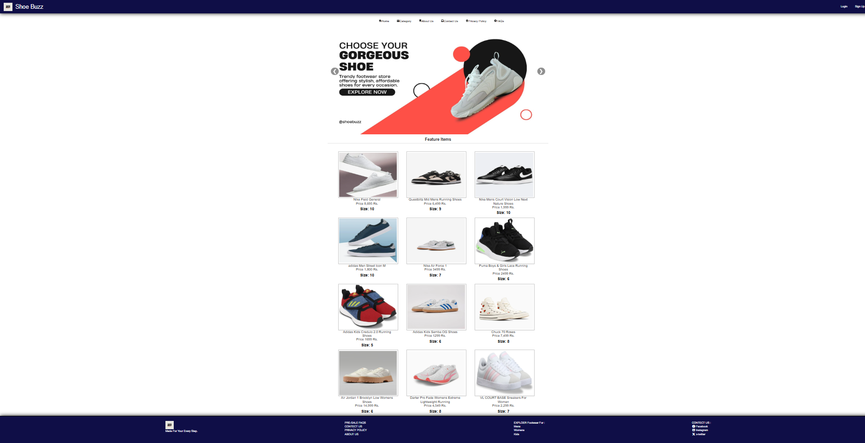

* **CLIENT REGISTRATION:**

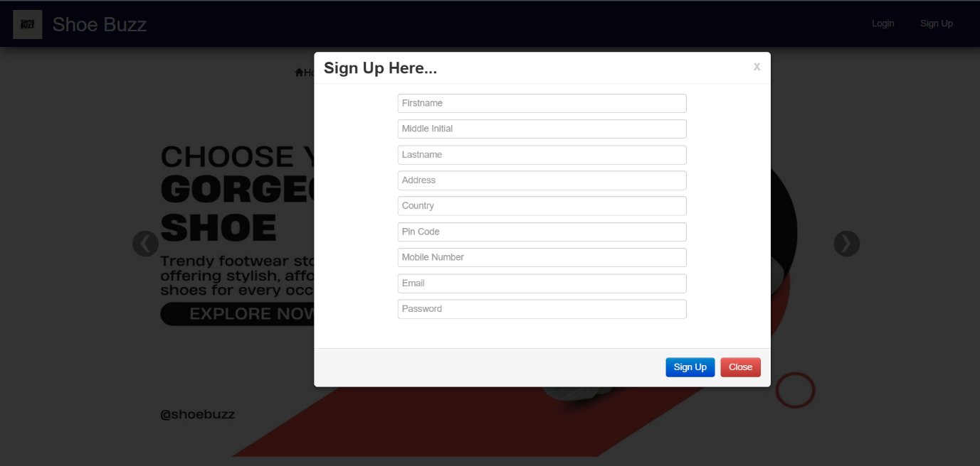

* **CLIENT LOGIN:**

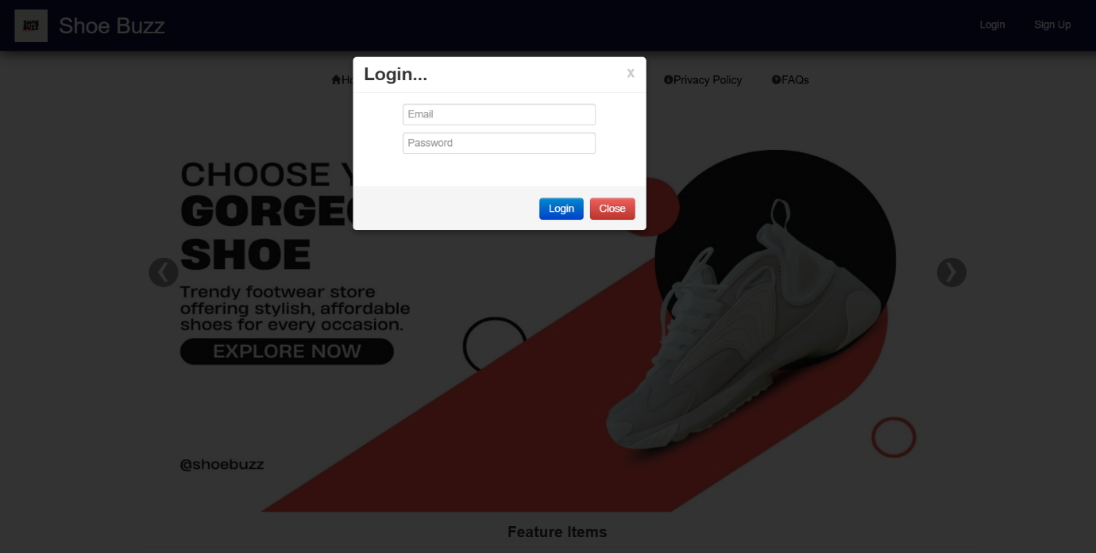

* **CLIENT PROFILE:**

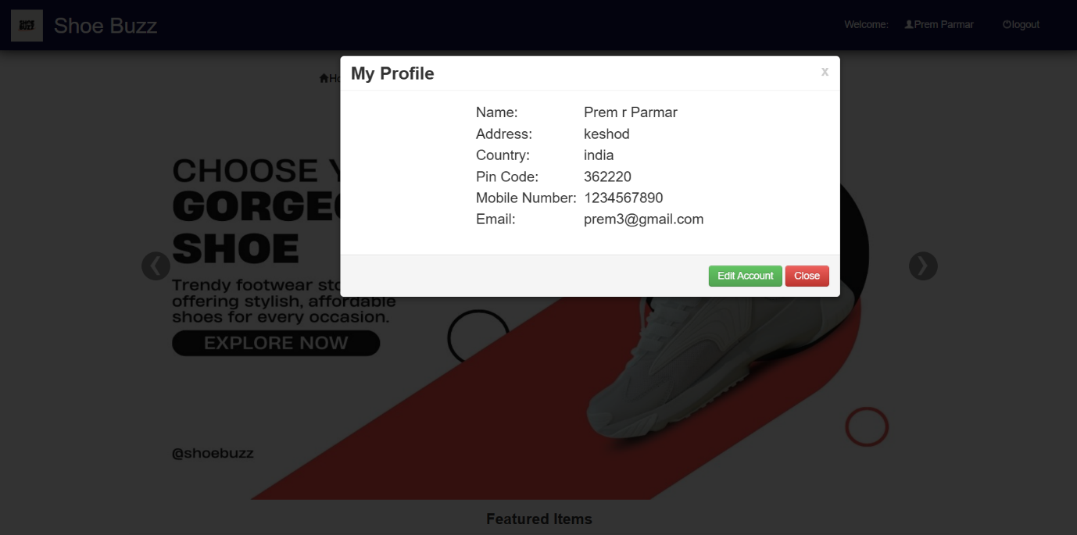

* **ABOUT US:**

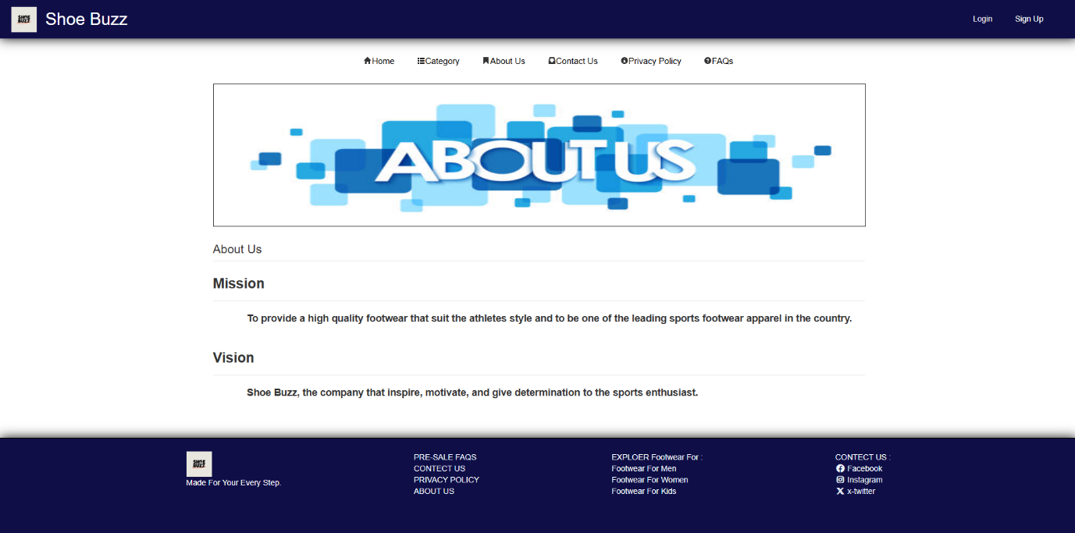

* **PRIVACY POLICY:**

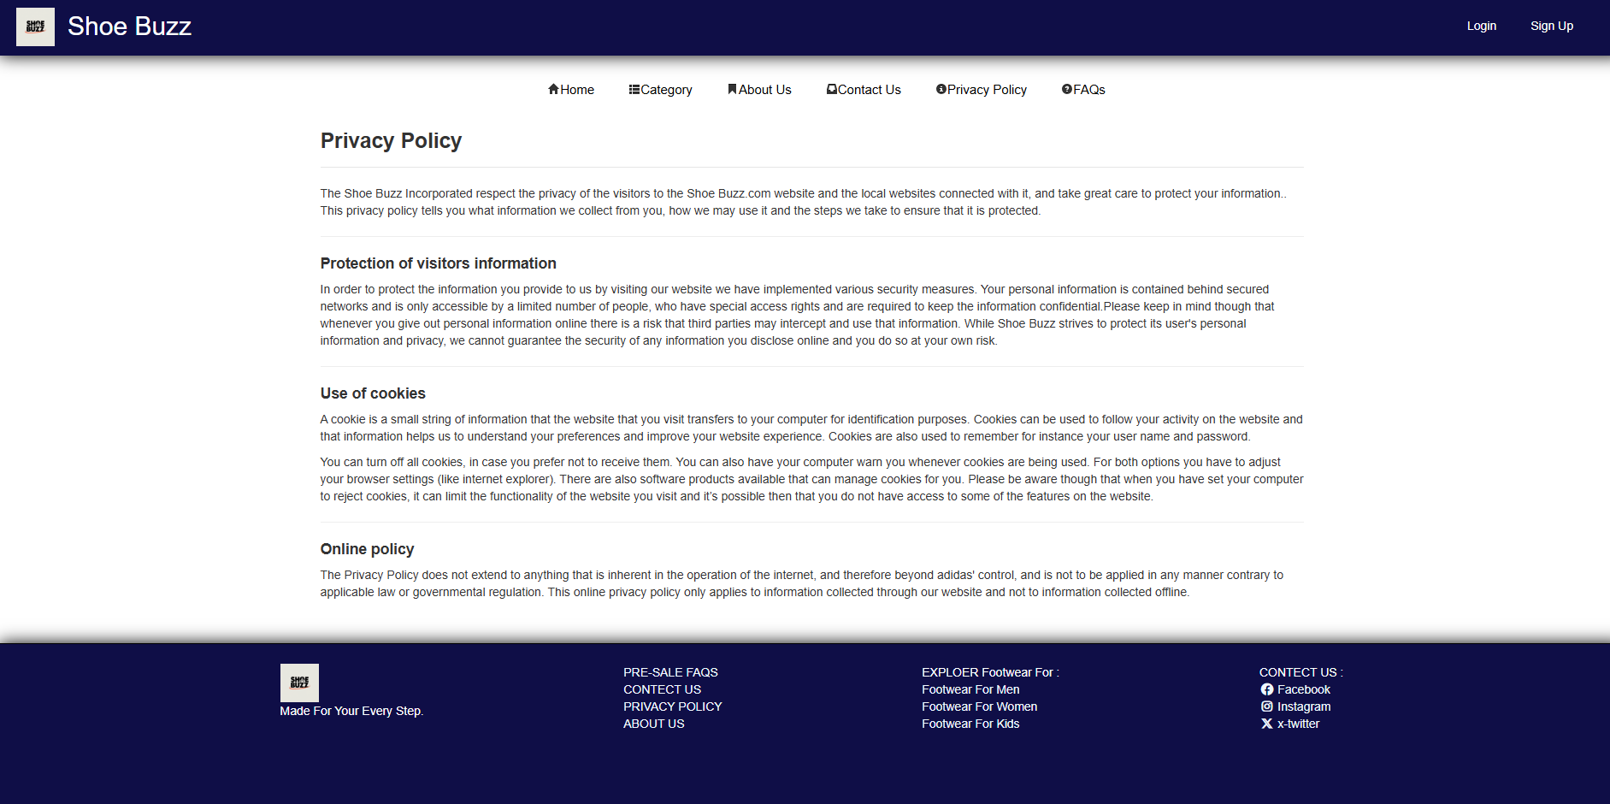

* **CONTACT US:**

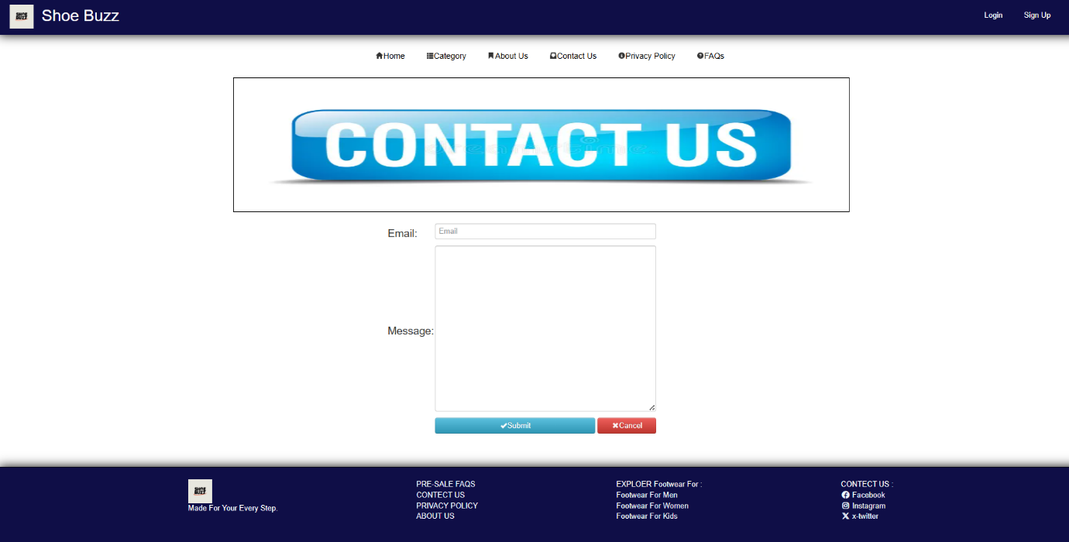

* **FAQs:**



* **CATEGORY:**
* **MEN:**

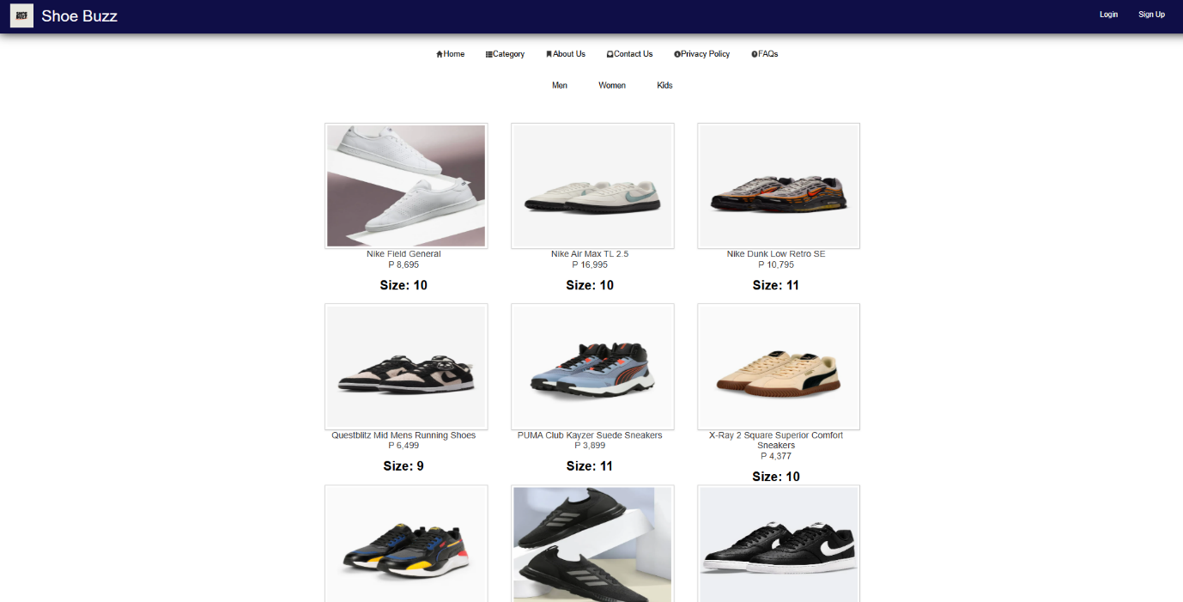

* **WOMEN:**

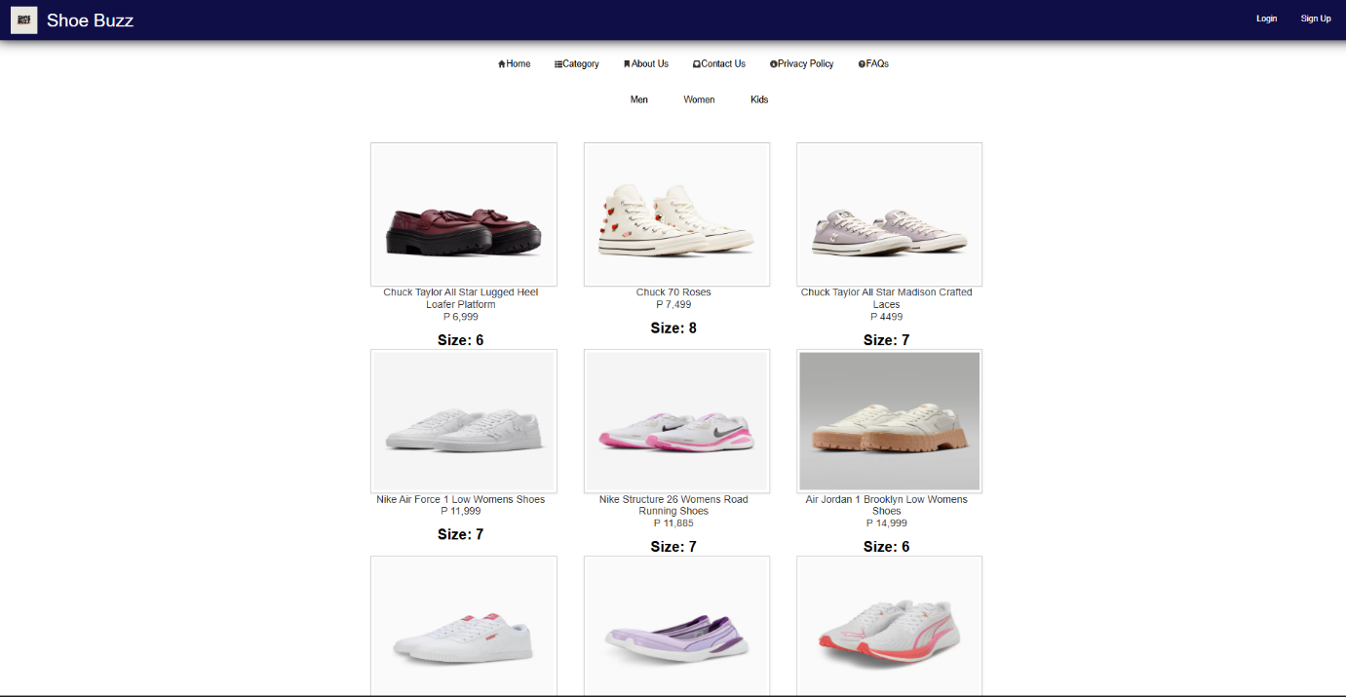

* **KIDS:**

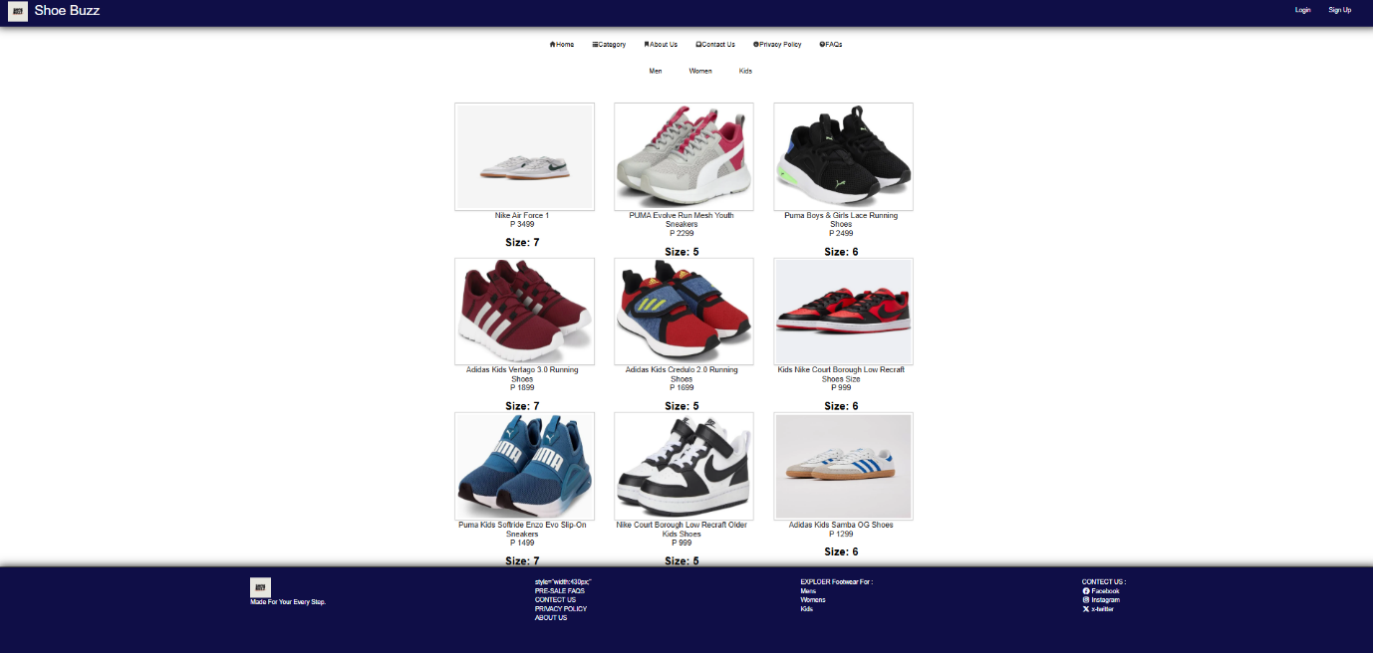

* **CART DETAIL:**

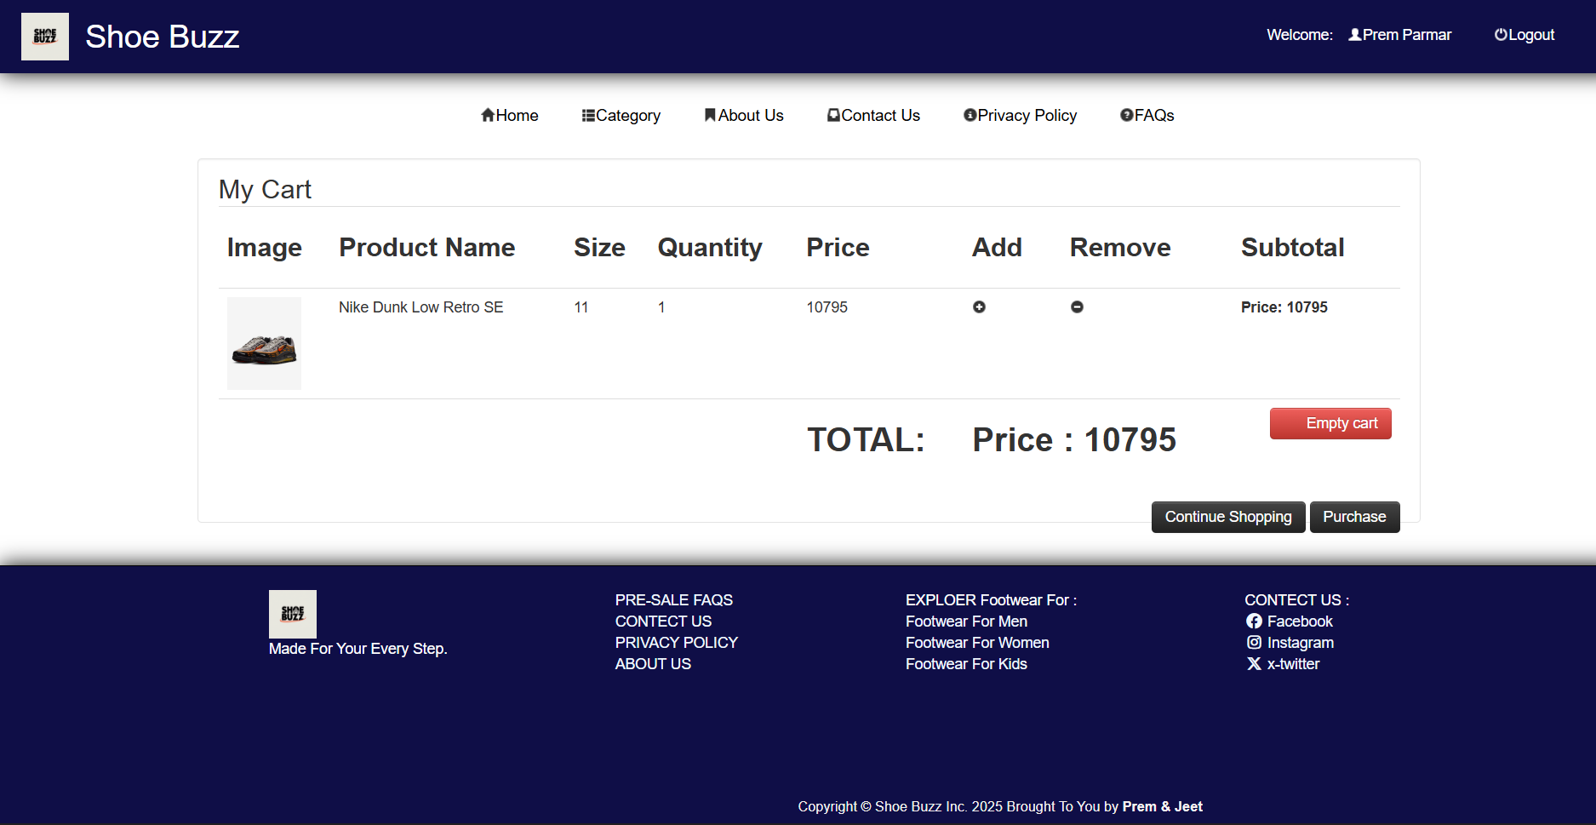

* **DELIVERY:**

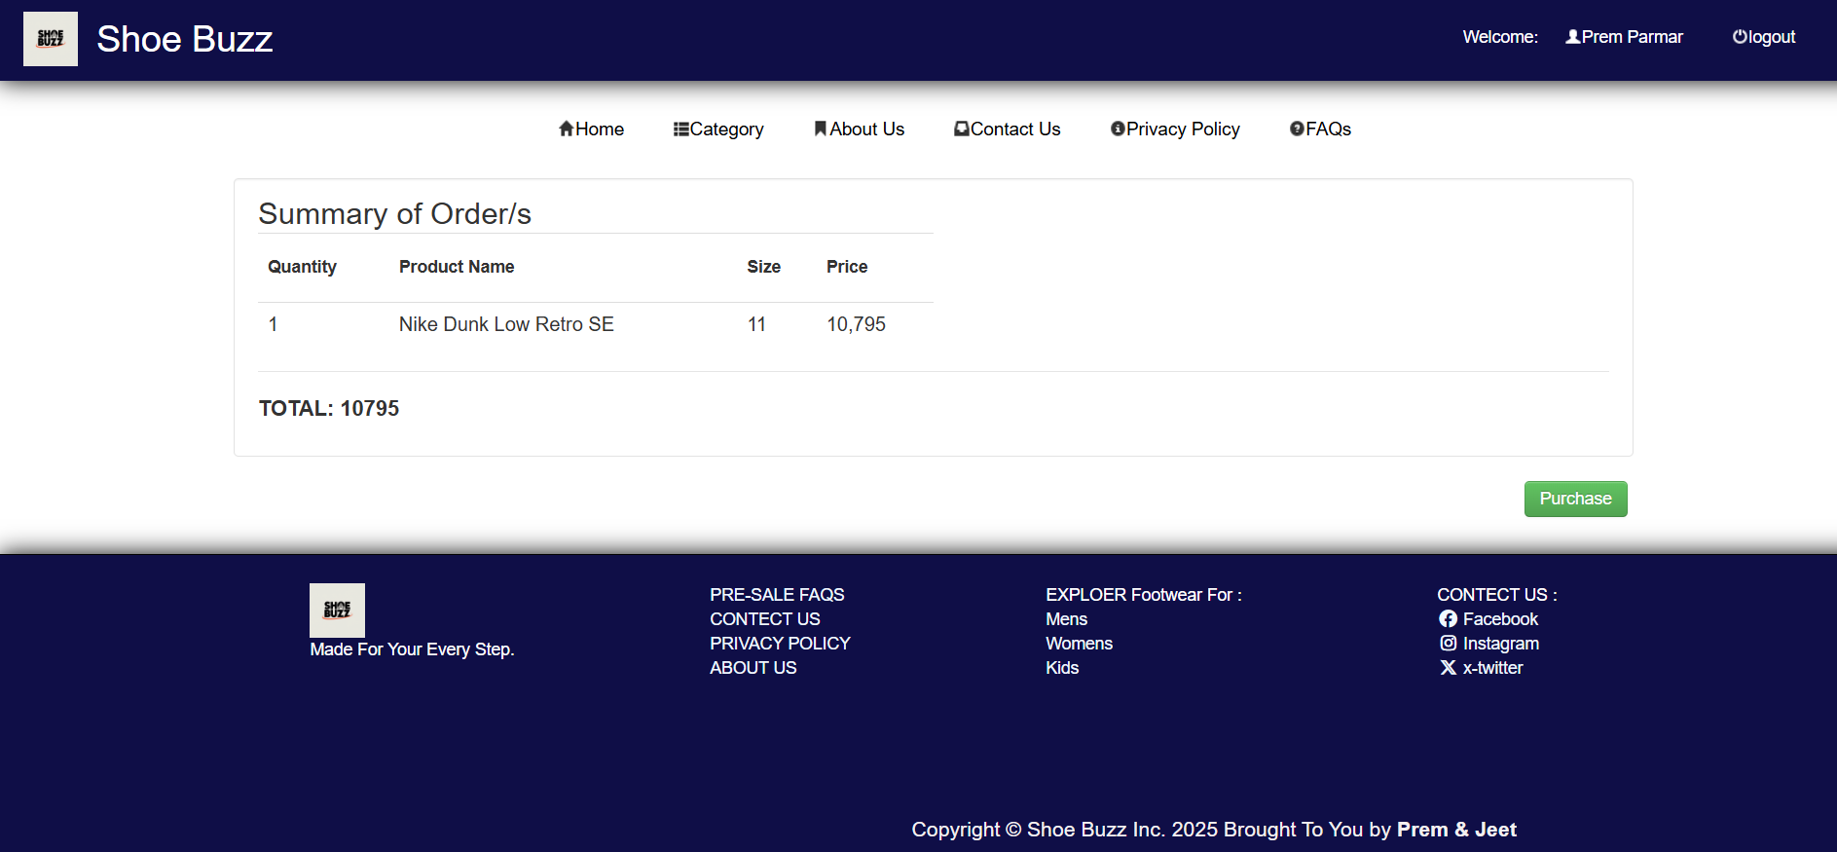

* **TESTING**
* Testing is the critical element of software of software quality assurance&represent the ultimate review of specification design and code generation.
* **MANUAL TESTING**
* **Login**

|  |  |  |  |  |  |  |
| --- | --- | --- | --- | --- | --- | --- |
| Case no | Scenario | Sr. no | Action | Expected Output | Actual Output | Result |
| 1 | Login | A | User forgets to enter the username\password | Message window saying “please enter the username\  password” | Message window saying “please enter the username\  password” | Pass |
|  |  | B | User enters wrong password /password | Message window saying “wrong  Username/  password" | Message windows saying “wrong username /password” | Pass |
|  |  | C | User enters correct username/password | Takes user to home page | Takes user to home page | pass |

* **Register**

|  |  |  |  |  |  |  |
| --- | --- | --- | --- | --- | --- | --- |
| Case no | Scenario | Sr. no | Action | Expected Output | Actual Output | Result |
| 1 | Register | A | User enter wrong detail | Message window saying “Customer Does not Exits” | Message window saying “Customer Does not Exits” | Pass |
|  |  | B | User doesn’t enter some records e.g. Name,Pass,Pin,  Contact | Message window saying “Name Should not be Null” | Message window saying “Name Should not be Null” | Pass |
|  |  | C | User enter correct U name, Pin , Pass.. All Detail | Message window saying “User valid for registration” | Message window saying “User valid for registration” | pass |

* **CONCLUSION**
* **Strong Market Presence:** Shoe Buzz has established itself as a dynamic and trend-focused brand, appealing to a wide range of customers through style, comfort, and innovation.
* **Customer-Centric Approach:** By prioritizing quality, affordability, and customer service, Shoe Buzz has built trust and loyalty among its growing customer base.
* **Digital & Social Impact:** Leveraging online platforms and influencer collaborations, Shoe Buzz has effectively expanded its reach and brand visibility in a competitive market.
* **Future Growth Potential:** With a solid foundation and a forward-looking strategy, Shoe Buzz is well-positioned for continued growth, product expansion, and increased market share.
* **BIBLIOGRAPHY**
* WEBSITE REFERENCE
  + - * <https://www.puma.com/>
      * <https://www.nike.com/>
      * <https://www.skechers.com/>
* **PROJECT TASK REPORT**
* Project Name: - **“Shoe Buzz”**
* Faculty Name: - **Prof. Manshi ponkiya**
* Student Name: - **Prem Parmar**

**Jeet Kotecha**

|  |  |  |  |  |  |
| --- | --- | --- | --- | --- | --- |
| Sr.no | Start date | End date | Project task | Faculty sign | Student sign |
| 1. | 1-7-2024 | 15-7-2024 | Information Gathering |  |  |
| 2. | 16-7-2024 | 22-7-2024 | Analysis |  |  |
| 3. | 23-7-2024 | 28-7-2024 | Database Design |  |  |
| 4. | 29-7-2024 | 29-8-2024 | System Design & Codding |  |  |
| 5. | 30-8-2024 | 10-9-2024 | Testing |  |  |
| 6. | 11-9-2024 | 25-9-2024 | Documentation |  |  |

